**Ludicrous Landslide Punishers – Project 2**

Michael Matcke, Omar Dahmash, Robert Lundberg, Tony Park

**App Name:**

* Ms. New Foodie

Project Idea:

* Similar to Yelp but better, this app will allow users to search food in their local area via the Yelp API but also see their top 3 recommendations for their region

What is the Minimum Viable Product (MVP):

* Search Bar for Food-type
* Zip Code
* *Yelp-API
* Database: Food businesses, type of foods
* This idea allows for Multi-Food Databases, Tags, Sub-Categories, extending databases

Tasks for Today:

* [x] Pick Project Idea: Food Ordering App
  + MVP:
    - Search
    - Business Details
    - Authentication: ? (bcrypt)
      * User Log-In:
        + Top 10 Businesses?
        + User can log in (hip hip hooray)
    - Models: User, Businesses, Key-Menu Items (top 3), Business-Review
    - The app helps user find the top three restaurants that provide that *thing* (best three tacos in the area)
    - Views: Handlebars.js (we’ll plan for it)
    - Controllers: Full CRUD
    - Postman:
      * JSON (BUSINESS-REVIEW)

{

“NAME”: “STRING”,

“STAR RATING”: INTEGER,

“REVIEW”: “STRING”

}

* + Nice To Have’s
    - Reviews
    - Autocomplete (Suggestions for Businesses)
* [x] Create and add contributors to Github (MIKE)
* [x] Create Branches (MIKE)
* [x] User Story (ROBERT)
  + User Story:  
    -As a User, I would like an easy way to find the best foods in my local area.  
    -I want to use an app that allows me to find the top 3 highest rated local restaurants for any food I want.  
    -I am a person who wants to use an app to find only the top food recommendations instead of every recommendation.
* [x] Create wireframe
* 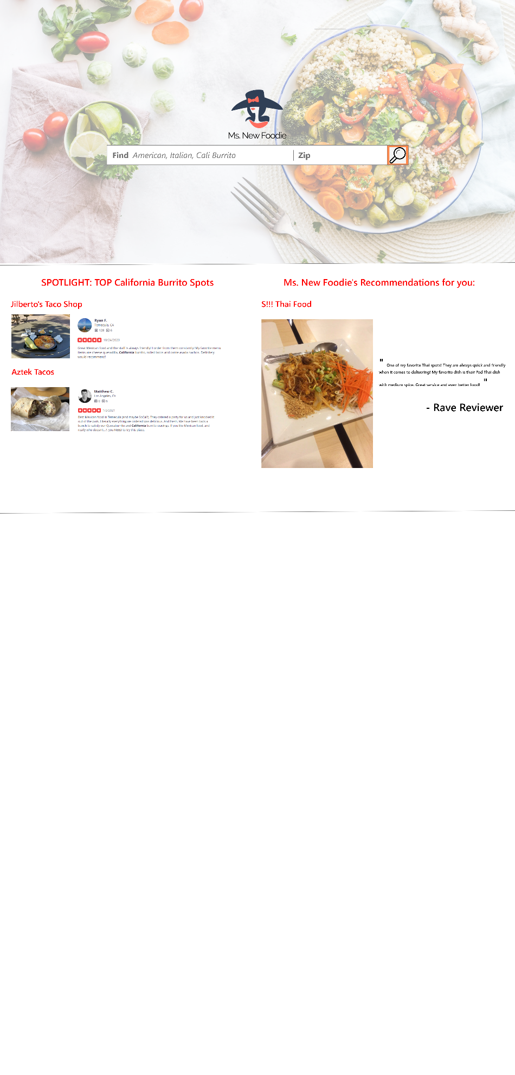
* [x] Submit project proposal for approval
* Calendar:
  + March 20, 2021: First Day, Project Development
  + March 23, 2021: Project Time
  + March 25, 2021: Project Time
  + March 27, 2021: Project Time
  + March 30, 2021: Project Time
  + April 1, 2021: Project Presentations

Notes:

* April Fools Joke?

Major Milestones:

March 29-30

[ ] Heroku Deployment

[ ] Project Run-Throughs

March 27:

[ ] MVP Feasible

[ ] User Testing / seeding

March 23

[] UI for Website: Tony and Robert

[] Front End of Website: Tony and Robert + Handlebars Setup

[] Github Verification: Mike

[] Backend Team: Databases + Research Yelp API

** CONFIRM THAT YELP API WORKS

March 26-29: BACK-END CRUNCH

March 29: Finalization

[ ] Presentation Slides

[ ] Timing of Presentation

[ ] April Fools

March 23

[ ] Front End 90-95% Complete

[ ] Goal to integrate front end and back-end

[ ] Robert and Tony jump to back end

[ ] Databases Made

March 25:

March 20, 2021: First Day Project Dev Proposal

April 1: Project Presentation